**LAB 1**

**1.1 Type and compile the program and remove errors and then run it.**

#Include <<iostream>> Using namespace Std int main () { Cout << welcome to the new batch\n; Cout < "it is our first class", Cout < "it is errorless",, Cout <we learn programming”; System(pause); return (0); }

**#Include <<iostream>> //the i of include was capital, extra < >**

**Using namespace Std //the u of using and s of std was capital, terminator was missing**

**int main()**

**{**

**//all cout's c was capital**

**Cout << welcome to the new batach\n; // inverted commmas were missing**

**Cout < "it is our first class", // < was missing and commas were in place of terminater**

**Cout < "it is errorless",, //two commas were present in place of a terminator**

**Cout < we learn programing"; //less than sign was missnig**

**return (0); // additional () brackets are present**

**}**

**SOURCE CODE AND OUTPUT**

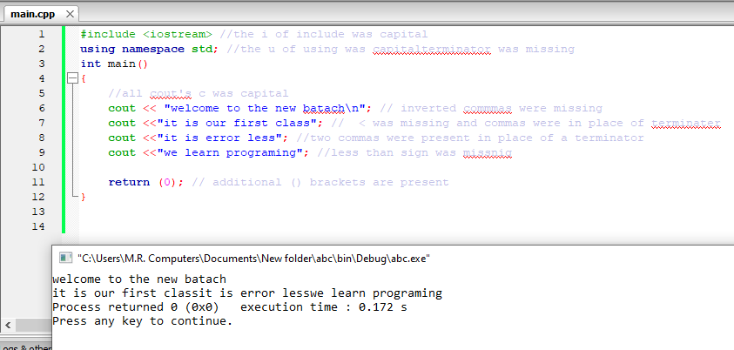

**1.2 writes a program to create a simple CV .Print all the requirements that are needed to be in making CV.**

**SOURCE CODE**

#include <iostream>

using namespace std;

int main()

{

cout<<"________________________________________________________________________________________"<<endl;

cout<<"|CV |"<<endl;

cout<<"|-- |"<<endl;

cout<<"|======FUTURE VISION====== |"<<endl;

cout<<"|To be the CEO of my very own software house |"<<endl;

cout<<"|======BIO DATA====== |"<<endl;

cout<<"|Nabeel Rizwan Quadri son of Syed Rizwan Quadri |"<<endl;

cout<<"|Date of birth 20-06-2000 |"<<endl;

cout<<"|mob. no. 03362319053 |"<<endl;

cout<<"|Email ID mr.nabeelrizwan@gmail.com |"<<endl;

cout<<"|======QUALIFICATIONS====== |"<<endl;

cout<<"|bachelor's in computer science from Hamdard university |"<<endl;

cout<<"|Inter from bufferone collage in pre-engineering |"<<endl;

cout<<"|Matric form Pakistani international school in biology |"<<endl;

cout<<"|======SKILLS====== |"<<endl;

cout<<"|Expert programmer in over 10 different languages |"<<endl;

cout<<"|======Communication Skills====== |"<<endl;

cout<<"|Expert in English speaking and writing |"<<endl;

cout<<"|======Interests====== |"<<endl;

cout<<"|Creative writing, Debating and reading books |"<<endl;

cout<<"|______________________________________________________________________________________|"<<endl;

return 0;

}

**OUTPUT**

